**Tension Force on a Diabolo Throw, Tristan Morse, Inquire Page # 1**

**Description of Observation**

When I was younger, I was given a toy that I played around with a lot called a “Diabolo.” The Diabolo, as shown in Figure 1, is a toy that is used for things like juggling and yo-yo-like string tricks. It uses friction between a string and an axle to spin the Diabolo, keeping it balanced on the string. I wasn’t able to do many tricks with it besides throwing it up very high, but when I threw it the highest I’ve thrown it, the Diabolo missed my string and rolled down a steep hill into a lake (I retrieved it! It’s still useable!). Because I loved this toy as a kid and am now a physics student, I want to get a better grasp on how much tension it takes on the string between the two sticks to throw the Diabolo up to a certain height.

**Visual**

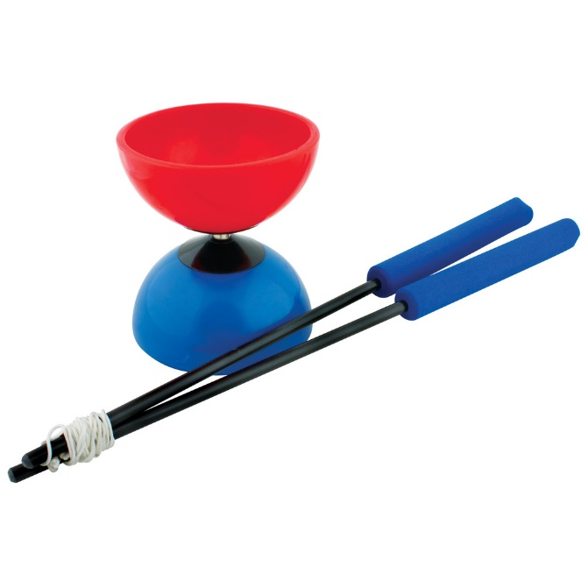

*Figure 1: Diabolo with two sticks and string (*<http://cdn.sweatband.com/yoho_diabolo_yoho_diabolo.jpg>*)*

**Physics Principles at Work**

A few physics principles at work in this observation are:

* Tension
* Projectile Motion
* Newton’s Laws
* Air Resistance
* Friction

**Inquire**

How much tension force with the string acting on the Diabolo does it take to throw it to a certain height?

**Assumptions and Data Required**

Assumptions:

* All parts are in good condition
* Diabolo is spinning at some rate to at least keep it balanced
* Diabolo is thrown from the center of the string
* There is no wind (with air resistance still present)
* Both sticks are raised at same rate
* Both sticks are raised from the same height
* Both sticks are raised with the same force on the Diabolo
* Diabolo isn’t tangled in the string
* Weight of Diabolo is distributed evenly

Data Required

* Length of string
* Height being thrown
* Weight of Diabolo
* Strength of person
* Air resistance on Diabolo
* Weight distribution of Diabolo
* Rotation speed of Diabolo